**COAL LAB 2**

**21k4834**

**TASK 1**

INCLUDE Irvine32.inc

.data

A equ 47d

A1 equ 39d

A2 equ 60d

A3 equ 85d

A4 equ 64d

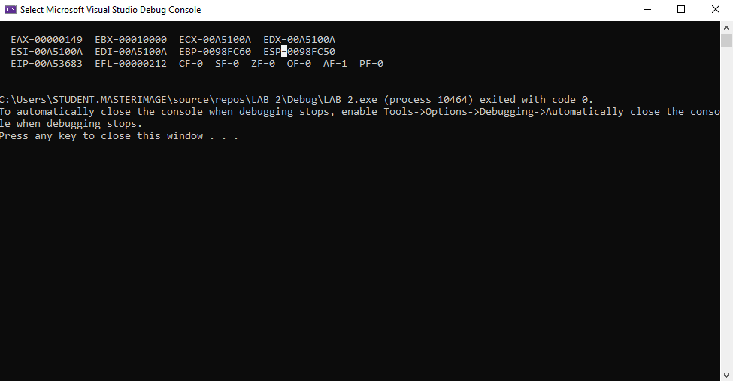A5 equ 54o

A6 equ 0Ah

.code

main PROC

mov eax, A

add eax, A1

add eax, A2

add eax, A3

add eax, A4

add eax, A5

sub eax, A6

call DumpRegs

exit

main ENDP

END main

**TASK 2**

INCLUDE Irvine32.inc

.data

A equ 30d

A1 equ 9d

A2 equ 186d

A3 equ 150d

.code

main PROC

mov eax, A

sub eax, A1

add eax, A2

sub eax, A3

call DumpRegs

exit

main ENDP

END main

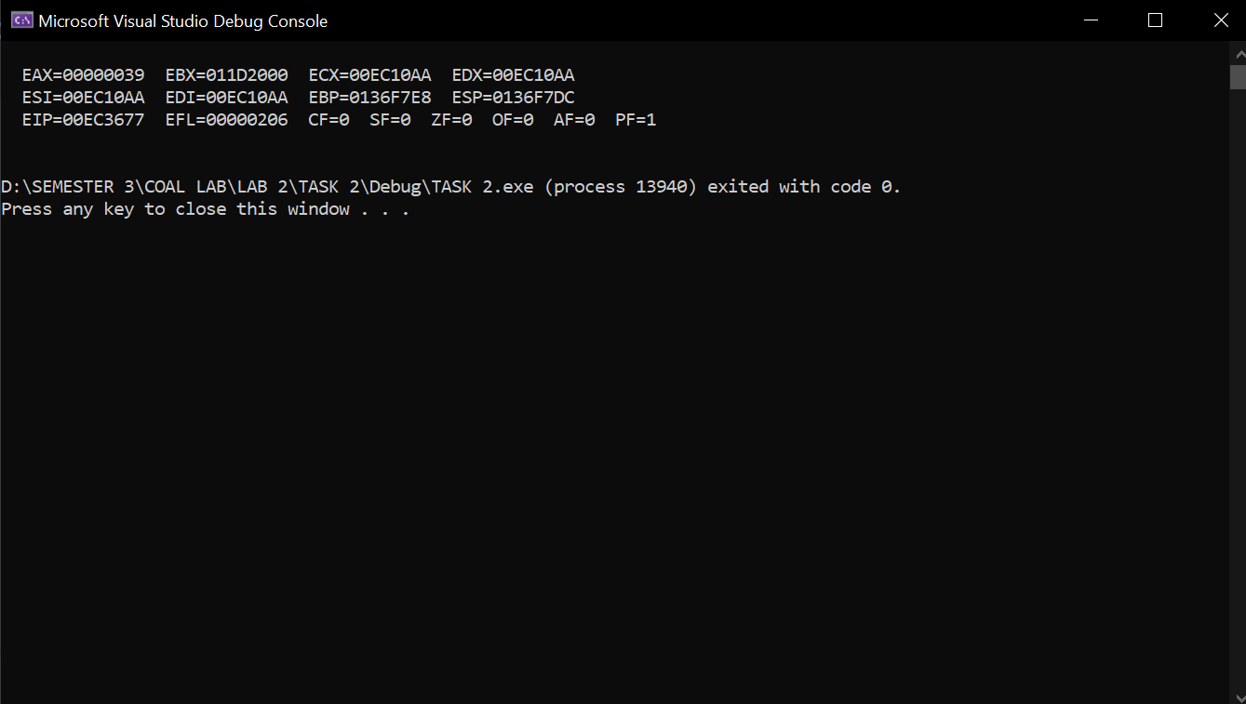

**TASK 3**

INCLUDE Irvine32.inc

.data

A equ 101110b

A1 equ 50Ah

A2 equ 6710d

A3 equ 1010001b

A4 equ 0Fh

.code

main PROC

mov eax, A

add eax, A1

add eax, A2

add eax, A3

add eax, A4

call DumpRegs

exit

main ENDP

END main

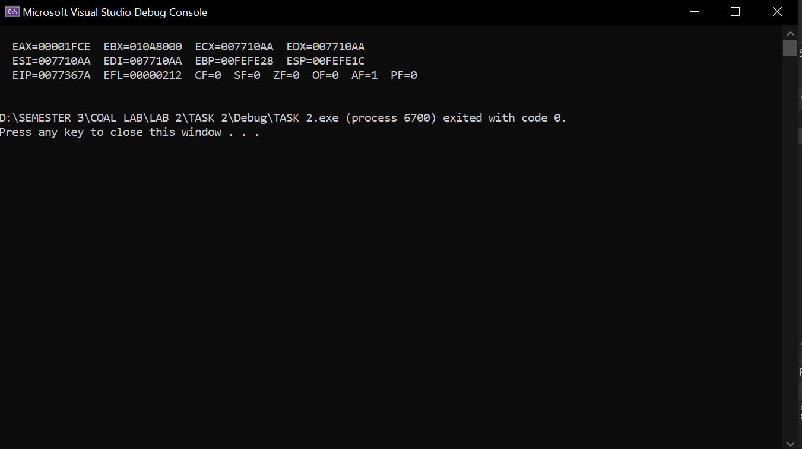

**TASK 4**

INCLUDE Irvine32.inc

.data

A equ 10001101b

A1 equ 0D83h

A2 equ 385d

A3 equ 10

A4 equ 1111101b

A5 equ 0Eh

A6 equ 0Fh

.code

main PROC

mov eax, A

sub eax, A1

add eax, A2

add eax, A3

add eax, A4

add eax, A6

sub eax, A5

call DumpRegs

exit

main ENDP

END main

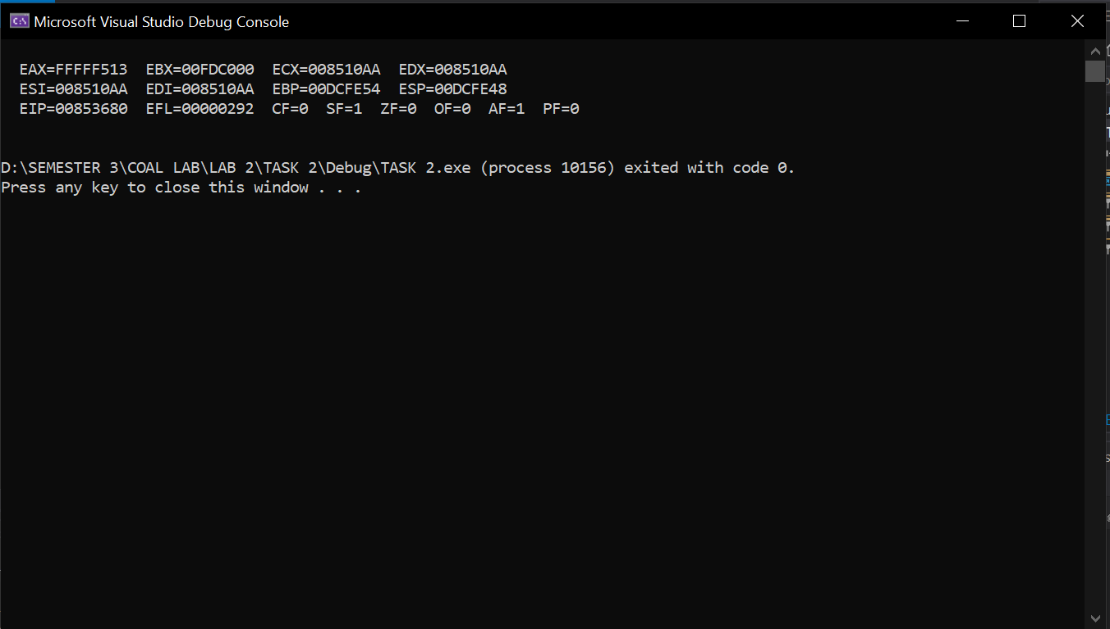

**TASK 5**

INCLUDE Irvine32.inc

.code

main PROC

mov edx, 0h

mov eax, 0Ah

mov ebx, 65o

mov ecx, 73d

sub edx, eax

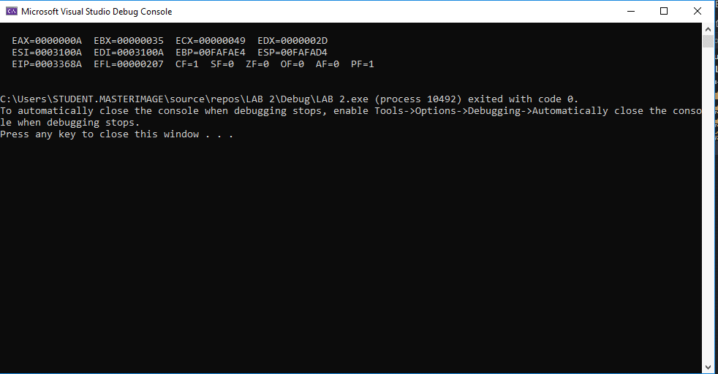add edx, 1

add edx, ebx

add edx, edx

sub edx, ecx

add edx, eax

sub edx, ebx

add edx, ecx

call DumpRegs

exit

main ENDP

END main

**TASK 6**

INCLUDE Irvine32.inc

.code

main PROC

mov eax, 0h

mov edx, 65o

mov ebx, 5ADh

mov ecx, 11110111b

sub eax, ebx

sub eax, eax

add eax, edx

mov ebx, 65d

mov edx, 150

add eax, ebx

sub eax, ecx

add eax, edx

call DumpRegs

exit

main ENDP

END main

